A)

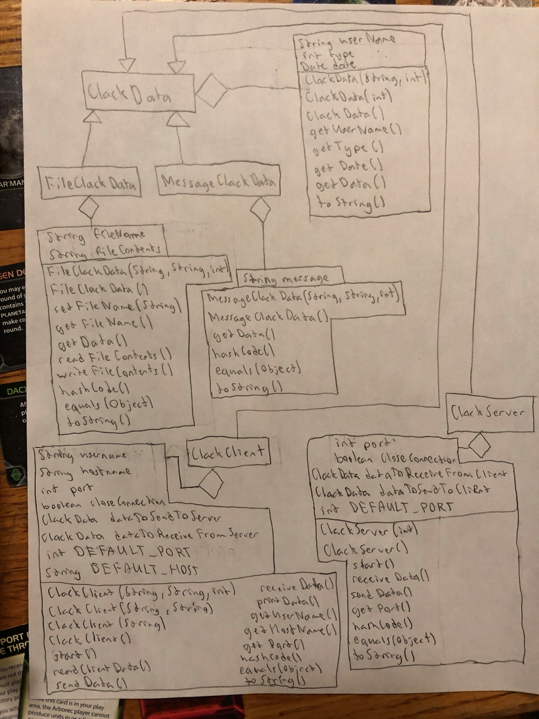

B) If a negative value for a port number occurs in our code, then the constructor will recognize that a negative value was inputted and change the port to the DEFAULT_PORT. We accounted for a null value for the user by putting in if statements to ensure exceptions do not occur within the toString methods.